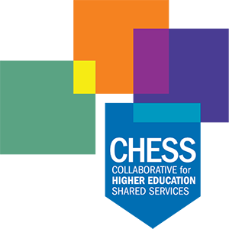

Date: Feb. 7
To: All Employees
From: CHESS Presidents
Re: Please complete CHESS ERP Survey by Feb. 14

Dear Colleagues,

As you know, {name of college} is a founding member of CHESS, the Collaborative for Higher Education Shared Services. Together with {insert other colleges (CNM, Clovis Community College, Northern New Mexico College, San Juan College, Santa Fe Community College)}, we are undergoing a multi-year project to modernize our administrative systems for human resources, finance, and payroll functions with a cloud-based service called Workday. Even if you’re not involved in the implementation of the system, all faculty and staff will use and interact with the new system when it goes live at the end of this year.

This Enterprise Resource Planning and Student Information System initiative – Mission: All Together 2025 – has multiple phases, first for administrative functions, which will go live in December. That will be followed by a new platform for our students. The result will be a more user-friendly, intuitive solution than the aging systems we currently have.

We Need Your Feedback! Please Submit Survey by Monday, Feb. 14
By completing the survey at the link below, you are helping provide an initial assessment of your understanding of this critical initiative. Don’t miss out on this opportunity to provide your feedback! Your input will assist in guiding the project forward.

About the Survey
- The survey should take approximately 5-10 minutes to complete.
- Please answer all of the questions/prompts.
- The survey will remain open until close of business on Monday, Feb. 14.
- Responses are confidential and personally identifiable information will not be requested or recorded.
- Periodic follow-up surveys will be distributed going forward to gauge employee readiness as the project progresses.

Click here for the survey!

Thank you in advance for your participation. If you have any questions, please talk with your Project Manager {insert name and contact info} or your {insert Change Manager name and contact info}. More information about this important project can be found on the CHESS website.

Sincerely,

{President}

